Number Rods: (First presentation) ECE Approx. 3 years;
(Ordering largest to smallest)

Start with a cosmic connection, engage the child’s senses.
Example: “We grow bigger and bigger all the time. One day you might be even taller than me! Numbers get bigger when we count them too. I have some special materials that help us see how numbers grow. Let’s go and get them.”

Connect to previous learning: “These look like the red rods, don’t they, do you remember how to carry them?”

Collect the materials together so the child knows where they belong. Hold the ends carefully, hands apart and walk sensibly to the table with the rod.

Place in random order. If they place it roughly, place the next one gently and say, “I really like it when we place them with no noise.”
Continue until all rods are on the table or large mat.
Review previous learning. “Which one is small? Which is the biggest?”
Model looking carefully. Say, “I wonder which one comes first?” Run a finger along the largest and say, “Look!” Pick it up and place it gently in the top left corner of the table.
Model looking carefully again. Select the next largest rod. Place it carefully in line with the largest one.

After placing another one in order, make a ‘mistake.’ Self-correct, putting it back and selecting the correct one.

Invite the child to place a rod (5), lining it up against the other rods neatly. Let the child place more (3 and 2)

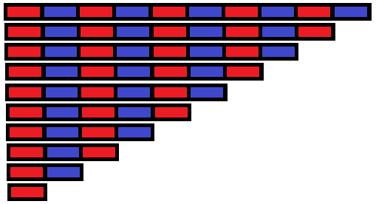
Repeat until all rods are in order. “We have made the number rod stair!”

Carefully help the child to return the rods to the shelf and invite them to use the material anytime they like to repeat the lesson.

Number Rods: (Second presentation) ECE Approx. 3 years.
Quality and Quantity of number, individual counting

Start with a cosmic connection, engage the child’s senses.
Example: “I’ve seen you make the number rod stair. Do you know why it is different to the red rods? It is different because of the stripes, stripes like a tiger! It is different too because it has a secret that helps us see how big numbers are. When they stand up like this, they look just like stairs and we can count our way up them. Let’s take them to the table and see what the secret is.”

Collect material one at a time. Place in random order on the table/mat.

“Which one is the biggest? Which one is smallest?
Choose three random rods (example 3, 5 and 2).

Pick up a rod (2) and say “This is two.” Place it in the child’s hand and say, Two, two hands, two feet, two.” Put it back on the table.

Pick up another rod (5), “This is five, five fingers, five toes, five.” Place it in the child’s hand as you say the number. Let them feel it is bigger.
Pick up the third rod (3). Say, “this is three, you are three! Three sides on a triangle, three.” Let the child feel the difference then place the rod back with the others.
Point to each one and name it then ask the child to …
Wriggle three
Put five on your knees
Circle three and cover two

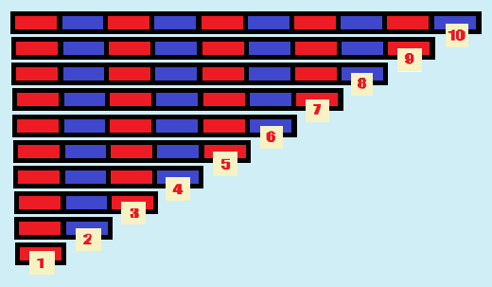
X Present other number rods until the child can confidently name all of the rods, number labels can be used.
Support the child to pack and return materials to the shelf.

Number Rods: (Third presentation) ECE Approx. 4-5 years.
(*Relevant to Stage 5 Numeracy)
Start with a cosmic connection, engage the child’s senses.
Example: If we go outside and you stand on the stairs are you as tall as me? Let’s go and see…Standing on the third stair makes you the same height as me! I have something really cool to show you with the number rods. Sometimes, if we put one on top of another it makes it the same size as the biggest one! But we have to find the right one each time or it’s too big, come on let’s see…”

Collect the materials together. Place in random order.

“Which one is this? Find 5. Can you order them?”
“You’ve done sandpaper numbers, cards and counters, spindle box, and number cards. You know how to count to ten and that zero is nothing! This lesson will show you how we can use all the things you know to make ten.”

Make the number rod stair, start at the top left corner of the table.
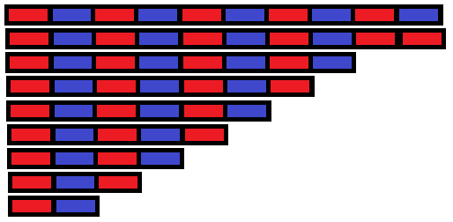
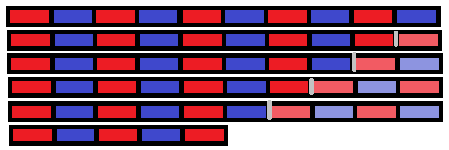
Point to the ten rod, “What is this?” Confirm answer. Point to nine, say, “How can I make this one the same as ten?” Take the one and place it on the end of the nine and ask, “is this the same? Yes! Nine and one make ten. Nine plus one equals ten.”

* * Colour variation is to clearly show where the pieces connect.
Show eight and two make ten - count on from eight, place two onto the end. Say, “Eight and two make ten.”

Ask, “How do we make seven up to ten?” Count on from seven, Let the child place three. Say, “seven plus three equals ten.”

Point to six and ask the child to make ten.

Place five by the ten rod, say “count on. How many do we need to make ten if we have five…” Count on together. “If I have five, I need five more!”
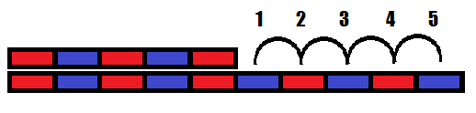
Separate. Review: e.g. six and what make ten?

X Show reversibility, “three and what makes ten?”
Seven plus what equals ten? (Problems can be written on mini whiteboards).
Return rods, one at a time to the shelf.

Cards and Counters: ECE 3yrs
Collect the materials together.

Start with cosmic connection, engage the child’s senses.
Place the material randomly on the right of the table. Comment on the number on the top card and how it looks like the sandpaper number. Ask, “Which number/digit is it?” Check they know numbers of the numbers by name.
Connect to previous learning.
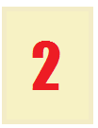
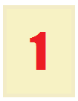
(We use these numbers for counting like the sandpaper numbers but now we have counters to show how many each number represents. This material is called cards and counters. It shows us how we can use the numbers to count ‘things’”).
* Take ‘1,’ place on top left corner of the table/mat.
Say, “One.” Take ‘2,’ place it beside ‘1,’ say “Two.” Repeat until all ten cards are in order.
Count together.

Place one counter in the middle below number ‘1.’ Say, “This is one.”
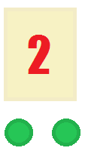
Place two counters each side of the two card, leaving a small gap in the middle. Count counters, “1, 2, two.” Slide finger above both counters.

Continue to lay out all cards and counters.
Ensure all odd numbers have a counter placed in the middle and all even ones have a gap through the middle.

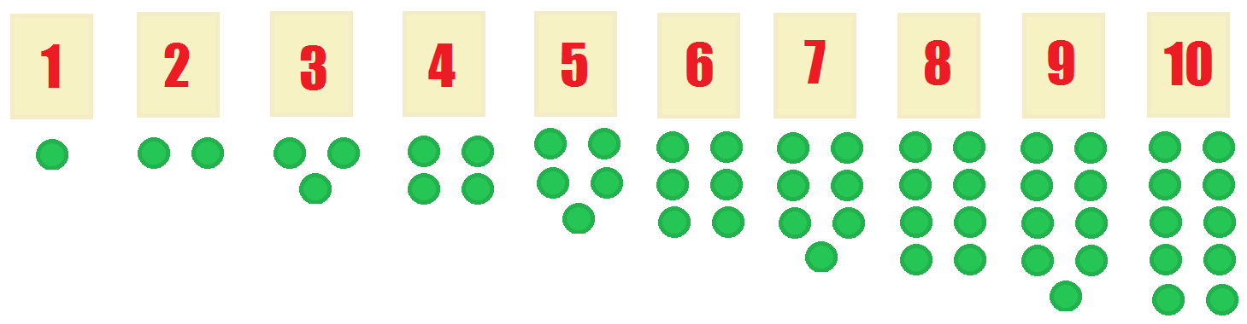

Cards and Counters: Continued… Introduction to the concept of ‘Odds and Evens.’
Place finger at the base of ‘1’ and start to move it down (make revving noise). Stop when it hits the counter. Dramatize.
Race through. Move corresponding number tile up.

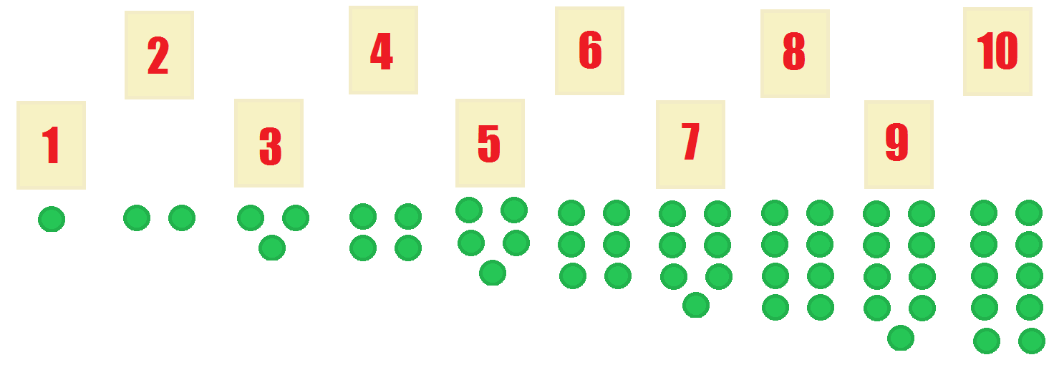

Run finger along bottom numbers. Say, “odd”; Run finger across top numbers, say, “even.”
Invite child to try.

Check, “Show me seven, show me five, where is two? Is three odd? Which one is eight? What is this one? (point to six).”
Inform child they can use cards and counters anytime they would like. Demonstrate how to put away. Return to shelf.

Place Value Cards: (Introduction to the digits of the decimal system) Approx. 4-5 years
The child should be familiar with hierarchies/golden bead tray.
Collect materials.

Start with a cosmic connection, engage the child’s senses.
Example: “If we take one golden bead, it doesn’t seem like much but if we take 1000 golden beads. it makes a big cube. If we go to the beach it seems like a big place but if we look closer, there are thousands and thousands and thousands of tiny grains of sand that make up the beach. There are too many to count but we can count some very big numbers. We can write really big numbers too. Come on, I’ll show you how we can learn to do that.”

Review/Check.
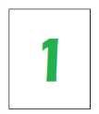
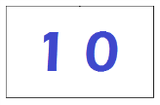
Lay the golden beads (1, 10, 100, 1000) on the mat. Pick up ‘1’ place value card and place it beside the ‘1’ golden bead. Point to the golden bead and say, “This is one.” Then point to the number and say, “This is one.”
Point to the ten bar and say, “This is ten.” Place the ten place value card next to it and say “This is ten.”
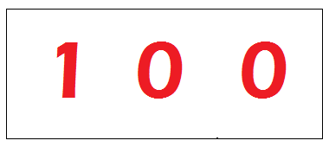
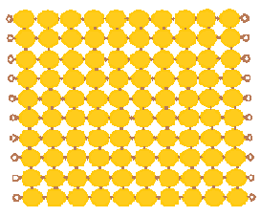
Point to the hundreds mat, say “This is 100.” Place 100 place value card beside it and say, “This is 100.”

Point to the thousands cube and say,
“This is 1000.” Then place the 1000 place value card beside it and say, “We write it like this, 1000.”
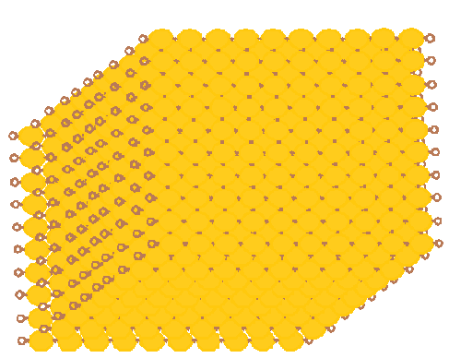
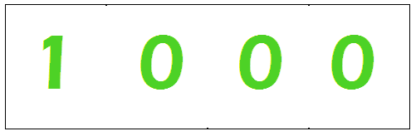
Ask child to go and get 1 thousand, 1 hundred, one ten and one 1.

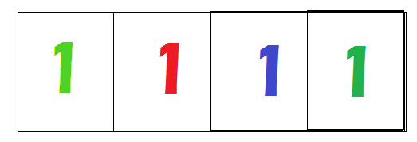
Show them the numbers on the place value cards then stack them to show the written
number.

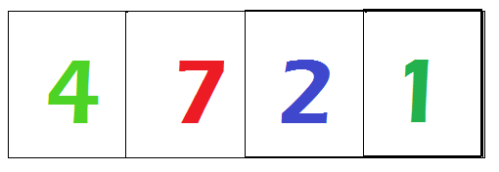
Then ask a child to get 3 tens from the shelf, show place value card 30, 3 tens is 30. Then 4 1000s, 7 hundreds, 2 tens and 7 ones.
When they’re back, show 4721 and say the number.

Addition Strip Board: (Counting-on, Making tens) Approx. 5-6 years
Check they can count to ten – lesson should be done after familiarity with Seguin Boards (teens), golden bead tray and bead stair.
Collect materials together.

Example: “I really like your shoes today; the blue is very cool, it’s like the sky that makes the sea look blue and the blue on the number rods. It’s like the blue on the addition strip board too…I think you are ready to do the addition strip board lesson now, let me show you how it works and what that cool blue means.”

Review rods making ten.
* Take the blue ‘9’ and place it on the top row of the addition strip board against the left edge. Say, “Nine.” Show 9 on the board.

Say, “I am going to make ten.” Point to the empty square and count ‘1.’ Pick up the ‘1’ red square, add it onto the end of the nine, say “1, Nine and one make ten.” Point to each quantity as you say it.

Add blue ‘8’ to the board. Say, “eight.” Count the two empty squares out loud. Pick up the red two strip and add it onto the end. Say, “eight plus two equals ten.”
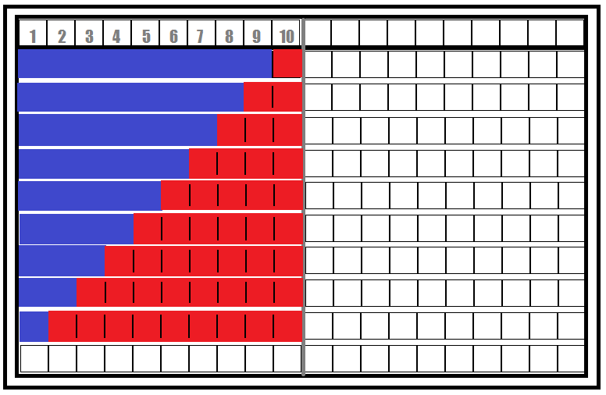
Continue until the strips are used and the board is complete.

Demonstrate packing up, starting with the large red strip, to the smallest, then filling in with the blue strips.

Inform the child they can use the board whenever they like. Next lesson, introduce addition problems.

